**Research Article**

**Isotope Localization of Ac-225 and Ac-227 in Mice**

Andrew L. Lakes 1, Dahlia D. An 1, Julian A. Rees 1, Rebecca J. Abergel 1,2

1 Chemical Sciences Division, Lawrence Berkeley National Laboratory, Berkeley, CA 94720

3 Department of Nuclear Engineering, University of California Berkeley, Berkeley, CA 94709

**Corresponding author:** Rebecca J. Abergel. [rjabergel@lbl.gov](mailto:rjabergel@lbl.gov).

**First author:** Andrew L. Lakes. [andrewllakes@gmail.com](mailto:andrewllakes@gmail.com).

**Words:** xxxx. **Figures**: xxxx. **Tables**: xxxx. **References:** xxxx

**Financial:** This work was supported by

**Running title:**

**Keywords:**

**Abstract:**

**INTRODUCTION**

1) Ac-225 isotope production

2) Ac-227 decay properties compared to Ac-225Ac-225 decays rapidly after the initial 9.9 day alpha decay into Fr-221, with a 45.5 minute pause for the half-life of Bi-213.

After this pause, there remains only 1 alpha decay (Po-213), accounting for 30% of the total alpha energy released. The Ac-227 decay chain begins with a low energy beta decay over a lengthy 7946 days, resulting in the therapeutically relevant Th-227.

The Th-227 alpha decays into Ra-223 after 18 days. After the 11.43 day alpha decay from Ra-223 intoRn-219, the remaining daughters decay with rapidity other than the 36 minute half-life of Pb-211, resulting in a final tally of5 alpha and 3 beta decays. After Pb-211 pause, there remains only 1 alpha decay (Bi-211), accounting for 20% of the total energy released. The total energy released during the Ac-227 decay chain is approximately 20% greater than the Ac-225 chain. However, the peak power output from Ac-225 occurs after only xxx hours with XXX MeV/day, whereas it takes xx days forAc-227 to hit xxx MeV/day

Ac-225 - 200 uCi = 18794542109 MeV/day @ 6.48 hours (plotoutpower) –Activity maximum is 13.68 hours (plotout) Ac-225- 200 uCi =

3) Long term dose effect of Ac-227

**MATERIALS AND METHODS**

**Materials**

3,4,3-LI(1,2-HOPO), referred to as HOPO, was XXXXXXXXXXXX. IgG1 antibody was purchased from Sigma-Aldrich. Trastuzumab was graciously donated from XXXXXXXXXX. 1,4,7,10-Tetraazacyclododecane-1,4,7-tris-acetic acid-10-maleimidoethylacetamide (DOTA-MMA) was purchased from Macrocyclics, Bradford reagent was purchased from Bio-rad, and tris(2-carboxyethyl)phosphine hydrochloride (TCEP HCl), L-glutathione reduced, and all other chemicals were purchased from Sigma-Aldrich.

**Activity counting**

All activity was counted with a Perkin-Elmer Tri-Carb 2910 TR. Dilutions of radiolabeled solution activity for injection were diluted with 10 mL of Ultima Gold LLT scintillation cocktail. For biodistribution, samples were ashed in a furnace, dissolved in nitric acid, and diluted into 10 mL Ultima Gold LLT scintillation cocktail.

**Radiolabeling**

*Caution: Lu-177 and Ac-225 are radioactive isotopes that may present serious health risks when incorporated. Experiments were performed in facilities specially designed for the safe-handling of radioactive materials at the Lawrence Berkeley National Laboratory (LBNL).*

For DOTA and HOPO radiolabeling, a dry heating block was used to heat ligands to 60 ºC for 2 hours in pH 7.4 10 mM phosphate buffered saline (PBS) at 200:1 excess Ligand:Metal. For antibodies-DOTA conjugates, a dry heating block was warmed to 45 ºC and antibody-DOTA conjugates (cysteine sites) were pre-incubated for 5 minutes, dissolved in 0.1M pH 5.4 ammonium acetate. Radionuclide in 0.05N HCl was added at 200x excess Ligand:Metal for 2 hours. Starting activity was based on an aliquot of the stock solution at equilibrium upon radiolabeling. These radiolabeled solutions were washed and buffer exchanged (10x volume 5 times) into PBS of pH 7.4, and aliquots of filtrate and retentate were taken for final activity and yield verification.

**Animal Handling**

All procedures and protocols used in the described *in vivo* studies were reviewed and approved by the LBNL Institutional Animal Care and Use Committee (IACUC) and were performed in AAALAC accredited facilities.

**Animal Injection**

Contamination is achieved by intravenous injection in a warmed lateral tail vein of the challenge chelated isotope. Animals are housed in metabolism cages, per randomization group (n = 3). Urine and fecal pellets are collected daily until necropsy. Blood, liver, kidneys, spleen, heart, lungs, thymus, abdominal remainder tissue (ART), skeleton, and soft tissue remainder samples collected at scheduled necropsy and processed for analysis. Counting is done on a gamma counter and on an alpha/beta LSC counter. Samples are counted promptly after processing and repeatedly over 100 days to allow for equilibration of Ac-227 daughter products.

**Biodistribution**

Biodistribution results are reported as percent recovered dose per mass (%RD/g) as excreta was collected alongside the organs and tissues.

**Dose Modeling**

Utilizing the kinetic dose results, we created an estimated future dose for HOPO, DOTA, and Trasztuzumab Ac-225/Ac-227 constructs. The input exact dose bolus was 200 nCi for Ac-225 and 1 nCi for Ac-227 (0.5% Ac-227 contamination), and assumed to be pure actinium without daughters (all activity is only actinium at t=0). Dose modeling was performed across two regimes: 1) interpolation within the actual recorded data set (0-10 days), and 2) extrapolation of future dose assuming no further change in final time point. Between real recorded time point values of 1 hr, 4 hr, 24 hr, 4 days, 6 days (and 10 days for Trastuzumab-DOTA only), small step changes were added for interpolation. Numerically solving the standard Bateman ordinary differential equations produced an activity per time correlation. Next, using the energy output for each decay along the daughter series’, a moving average of power per count of activity (MeV/minute / CPM) for each time step was found, to get MeV/count. 100% efficiency of counting was assumed per decay. For time points within the real recorded time points, a monotonic cubic spline was used to gather activities, where activity past the real data assumes no change in biodistribution, and only decay occurs (see **Figure Sxxx**). Power per mass (MeV/(g*day)) was found per time step based on organ masses, and was numerically integrated to convert to energy per mass for conversion into units of Grey. Unequal variance standard deviation was also modeled via cubic spline interpolation and numerical integration for real data points with error propagation, and 95% confidence intervals were determined via assuming n=5 for each future timepoint beyond the real data of n=5.

**RESULTS**

After injection of 2 nCi/g of Ac-225 construct with up to 0.5% Ac-227 contaminant to either 1) female Swiss-Webster mice with DOTA-Ac-225 or HOPO-Ac-225, or 2) female NOD SCID PDX mice with Trastuzumab-DOTA-Ac-225, biodistribution of Ac-225 and Ac-227 was investigated over several timepoints. Biodistribution was compared via recovered dose per gram (RD/g) or localization ratio (LR).

**Biodistribution**

As is typical with HOPO biodistribution in native mice, liver uptake was high for both Ac-225 and Ac-227, with lower distribution to other organs throughout 6 days after injection (**Figure 2**). LR for RD/g of Ac-225/Ac-227 tended to be at or greater than unity for the heart, lungs, kidneys, liver, and carcass. LR also trended a decrease from above unity in earlier timepoints to at or below unity in later timepoints for all organs except the spleen and ART. For the organ with greatest localized uptake with both isotopes, the liver, the LR at the final time point at 6 days was not statistically significant from unity.

DOTA biodistribution in healthy mice was also typical with activity locating heavily in the kidneys initially compared to other organs, and rapidly dropping activity with quick urine excretion (see **Figure excreta???)**. Ac-227 distribution, however, indicated lingering carcass content. Comparing LR, the Ac-227 recovery was greater than Ac-225 across the board, an opposite result to DOTA-Ac distribution.

In NOD SCID her-2 positive patient derived xenograft mice treated with targeted Trastuzumab-DOTA, RD/g biodistribution was typical where blood circulation content decreased over time, with increasing spleen as the largest uptake, followed by liver and tumor uptake. LR for Trastuzumab-DOTA-Ac was near unity for all organs other than blood and spleen. As the blood LR increased for Ac-225, so did spleen, but with only a single significant difference at the final 10-day timepoint for the spleen LR (n=5, mean = 2.94 ± 1.43 stdev., one-tailed P-value = 0.02 vs. unity).

**Dose Modeling**

After dose interpolation and extrapolation of each organ’s RD/g assuming an equal 200 nCi Ac-225 and 1 nCi Ac-227 (0.5%), output measurements of dose vs time, dose ratio (Ac-227/Ac-225) vs time, and dose/day vs time were calculated.

*HOPO-Ac*

Considering the RD/g values from **Figure 2** are proportional to relative organ dose, HOPO showed greatest dose to the liver for both Ac-225 and Ac-227, with a cumulative Ac-225 mean dose of 4.26 Gy (95% CI 3.97-4.54 Gy) which remained steady after 125 days (**Figure 2A**). HOPO-Ac-227 at 125 days showed an increasing mean dose of 0.323 Gy (95% CI 0.30-0.36 Gy), and after 7946 days, a mean of 22.4 Gy (95% CI 20.3-24.5 Gy) (**Figure 2B**). When comparing the dose ratios of Ac-227/Ac-225 for HOPO, due to the increasing values of Ac-227 cumulative dose, the dose ratios were initially small, and increased to a range of roughly 5-20 at 7946 days (**Figure 2C**). When comparing the dose per day (Gy/day), HOPO-Ac-225 showed a maximal mean of 0.254 Gy (95% CI 0.249-0.258) at 1.33 days (**Figure 3A**) in the liver, whereas HOPO-Ac-227 showed a maximal mean of 0.039 Gy (95% CI 0.035-0.042) at 200 days in the liver and continued to decrease as Ac-227 decayed (**Figure 3B**).

*DOTA-Ac*

DOTA-Ac had the greatest Ac-225 dose to the kidneys, with a dose of 0.0167 Gy (95% CI 0.0150-0.0183 Gy) at 100 days (**Figure 2E**), where Ac-227 only showed roughly 20% the dose at 0.00331 Gy (95% CI 0.00315-0.00347 Gy) (**Figure 2E**). However, the estimated Ac-227 cumulative dose continued to increase to 0.311 Gy (95% CI 0.296-0.326 Gy) after 7946 days (**Figure 2E**) for a Ac-227/Ac-225 dose ratio of roughly 20 times at 7946 days (**Figure 2F**). Compared to the kidneys, the carcass for Ac-227 showed roughly 2x higher cumulative dose. The dose per day for DOTA-Ac-225 in the kidneys showed a maximum at the initial time point of 1 hour, with 3.02E-3 Gy/day (95% CI 2.95E-3 - 3.09E-3 Gy/day) (**Figure 3C**), with a DOTA-Ac-227 maximum at 200 days with only 5.35E-5 Gy/day (95% CI 5.09E-5 – 5.60E-5 Gy/day) (**Figure 3D**), and the DOTA-Ac-227 carcass showing roughly twice the dose per day.

*Trastuzumab-DOTA-Ac*

Trastuzumab-DOTA-Ac showed uptake primarily in the spleen, with a 125-day dose maximum of 20.4 Gy (95% CI 17.0-23.8 Gy) for Ac-225 (**Figure 2G**), and after 7946 days Ac-227 showed a slowing cumulative dose of 33.7 Gy (95% CI 29.6-37.7 Gy) (**Figure 2H**) for a dose ratio of Ac-227:Ac-225 of roughly 1-5:1 for all samples but blood (**Figure 2I**). The dose per day, however, showed a lower peak dose rate for the spleen of 0.879 Gy/day (95% CI 0.708-1.05 Gy/day) for Trastuzumab-DOTA-Ac-225 (**Figure 3E**), and at 200 days 0.0579 Gy/day (95% CI 0.0509-0.0649 Gy/day) for Trastuzumab-DOTA-Ac-227 (**Figure 3F**).

**DISCUSSION**

Mice in each group were given a target dose of 2 nCi/g Ac-225 with up to 0.5% Ac-227 contaminant. At the final time point of biodistribution sampling, it was assumed that distribution was now static as a worst case scenario estimate (with decay still occurring). To estimate dose toxicity for NOD SCID mice with an antibody-DOTA-Ac conjugate, we extrapolated an estimated future dose using an 8 nCi/g Ac-225 injection (40% MTD of antibody-DOTA-Ac-225 conjugates (cite Lakes 2019 Ac-225, mcDevitt2001 science)). Considering Lakes2019 maximum tolerated dose is based on toxic effects of pure Ac-225 (no Ac-227) out to 35 days, it may be assumed that toxic effects of only Ac-225 beyond 35 days are negligible compared to acute effects due to the short half-life of Ac-225 (10 days). Therefore, acute dose rates up to 35 days may be taken as guideline estimates for an organ tolerated dose rates. This does not speak for long term dose effects of Ac-227, however, which may not be comparable to acute effects. For this, it is helpful to look at XXXXXXXXXXXX (study of long term toxicity of alpha emitter per organ?)

Trastuzumab-DOTA-Ac conjugates showed expected biodistribution considering antibodies are often distributed to immune-functioning organs such as the spleen, liver, and targeted tumor (CITE ADC DISTRIBUTION). Also typical was DOTA-Ac complex biodistribution, where DOTA has shown rapid clearance in both our study and in literature compared to antibodies (cite Actinium-225 in targeted alpha-particle therapeutic applications – Scheinberg 2011). Even though renal clearance is the main mechanism (see kidney uptake in **Figure 2B/E**.), the quicker clearance results in greater than an order of magnitude lower kidney dose (see **Figure 4D/G**.), and is more highly tolerated than in antibody drug conjugates. Contrasting to DOTA, HOPO typically shows rapid hepatic clearance, and thus liver and solid excreta show the largest portions of distribution (cite Rees2018 sci reports).

1. How much dose is too much dose? What are current safe limits based on literature?

The International Committee of Radiation Protection(ICRP) defines the ‘threshold dose’ as an amount of radiation dose to cause an observable effect in only 1% of individuals (estimated dose for 1% incidence, ED1), but not so far as to say there is no biological effect below that threshold (CITE ICRP).

In general, low LET radiation is less effective at low doses than at high doses (cite ICRP). This is partly due to a certain amount of cellular repair capacity in offsetting the oxidative stress induced by photon therapies creating oxygen free radicals in the aqueous environment (cite?). However, high LET radiation retains its potency even at low doses due to direct DNA lesion mechanisms (cite?).

Different tissues’ proliferation rate greatly influences the radiotolerance observed.

Similarly, the relative biological effectiveness weighting factor of alpha to gamma dose is taken as 20:1.

Acute radiation syndrome for humans is an LD50 of approximately 6-7 Gy with medical assistance, or 3.3-4.5 Gy without (UNSCEAR Annex G, 1988, ICRP).

Behr 1999 (High-linear energy transfer (LET) alpha versus low-LET beta emitters in radioimmunotherapy of solid tumors: therapeutic efficacy and dose-limiting toxicity of 213Bi- versus 90Y-labeled CO17-1A Fab' fragments in a human colonic cancer model.)

Initial blood dose 5-8 Gy for Bi-213-Fab’ fragments

Kidney dose < 35 Gy over for Bi-213-Fab’ fragments

Tissue weighting factors:

Lung – 0.12

Liver, kidney, spleen, intestines, bladder etc. – 0.05

Whole body – 1.0

(Canadian Radiation Protection Regulations, Schedule 1 (SOR/2000-203))

In the Unites States, the annual radiation exposure limits for radiation workers is 50 mSv for whole body exposure (cite OSHA.gov), which if taken as alpha radiation (20:1 equivalency for Sv:Gy with alpha radiation), is the equivalence of approximately 2.5 mGy. At this dose exposure, the risk of death is not measurably increased. However, the risk of diseases typically treated via radiotherapy greatly outweighs the risk of the therapy itself. For radiotherapy patients using Zevalin (anti-CD20 conjugate with In-111/Y-90), doses are much greater. After an imaging dose of 5 mCi In-111, and a therapeutic dose of 0.4 mCi/kg Y-90, dose ranges received were: spleen 4.2-23.0 Gy, liver 2.6-12.0 Gy, lungs 1.4-5.3 Gy, kidneys 0-0.66 Gy, 0.29-1.2 Gy red marrow (cite Wiseman 2002, Cancer. Radiation dosimetry results for Zevalin radioimmunotherapy of rituximab-refractory non-Hodgkin lymphoma). Considering the short half-lives for In-111 (67.3 hours) and Y-90 (64.1 hours), these doses can be considered as acute. Comparing our mouse data to these values, it is clear that the short term Ac-225 dose is similar or less than the Zevalin example, with the largest maximum daily dose of Trastuzumab-DOTA-Ac-225 with an upper end 95% CI of 23.8 Gy cumulative dose, or upper end 95% CI of 1.05 Gy/day.

While acute doses XXXXXXXX, long term doses deplete the stem cell compartments, and increase proliferation of multipotent cells (ICRP, (Fliedner et al., 2002)). It has been shown that long term dosing allows for a greater total cumulative dose compared to acute doses, and dose rate is indicative of dose tolerance (cite ICRP, Muksinova and Mushkachyova, 1990).

Considering long term Ac-227 exposure is not directly comparable, estimates may still be made to long term safe exposure rates. The Trastuzumab-DOTA-Ac-227 dose per day is in the order of 5 mGy/day between 100-7000 days for the highest exposed order, the spleen, and 2 mGy for the liver at maximum. This corresponds to approximately 1.8 Gy/year for the spleen, and 0.73 Gy/year for the liver. Chronic radiation syndrome for humans requires an annual full-body dose of 0.7-1.0 Gy per year, and cumulative dose greater than 2-3 Gy for 2-3 years (**cite ICRP,** Barabanova et al., 2007 - Chronic radiation sickeness 1479 due to uniform irradiation. Moscow). While these individual organ values are greater than this, it is isolated to an organ, and so organ equivalencies make this number below this threshold. The spleen and liver organ equivalency is 0.05, which produces approximately 0.09 Gy/year for the spleen and 0.037 Gy/year for the liver.

1. Results of extrapolation
2. How did this compare to literature MTD?
3. Limitations of extrapolation of dose after 10 days (e.g. worst case scenario
4. Considerations for future of Ac-225 therapies

HOPO showed much greater dose than DOTA due to the greater bodily residence time for excretion via the gastrointestinal tract.

dose

For instance, if real time points are from 0-10 days, and we extrapolate out to Ac-227 half-life (7946 days), cubic spline is used between 0-10 days, and from 10.25-7946 days are extrapolated by the final activity and decayed as if stationary according to the Ac-22X moving power average per timepoint. The difference is small for Ac-225 since it is already at equilibrium, but it is significant for Ac-227.

There is a 1:5-10 ratio of 225/227 dose for DOTA (10-100:1 225/227) vs DOTA-Tras (100-500:1 225/227) that can be seen from the dose biodistribution (**Figure S2**). Even though the Ac-227 dose is higher for the antibody compared to DOTA-only with Ac-227, the Ac-225 dose with the antibody is 5-10 times higher than the Ac-227 dose with the antibody, leaving more therapeutic headroom (**Figure S2**).

**CONCLUSIONS**

**REFERENCES**

Use the "Insert Citation" button to add citations to this document.

**FIGURES**

**A**

**B**

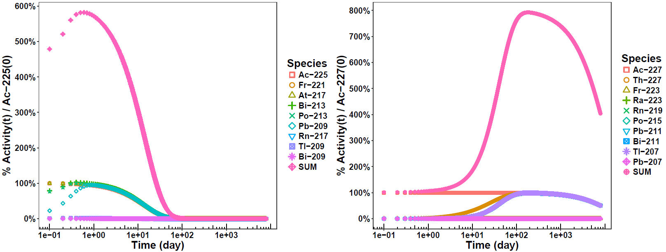

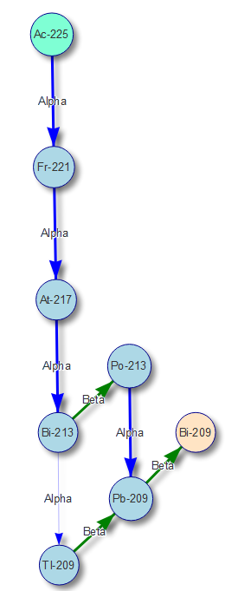

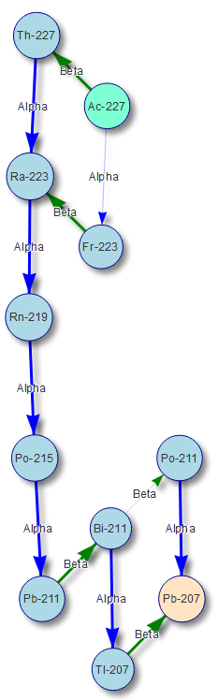 

**Figure 1.** Comparison of **A)** Ac-225 and **B)** Ac-227 decay. **Left:** Vertical placement is in relation to proton count. Parent is in teal, final daughter is in salmon, intermediate species with >0.1% incidence are blue. Line thickness indicates probability (thicker is greater probability). **Right:** Species activity in relation to pure actinium parent at t=0 [% Activity of Species(t) / Ac-22X(0)]. SUM is total of all species.

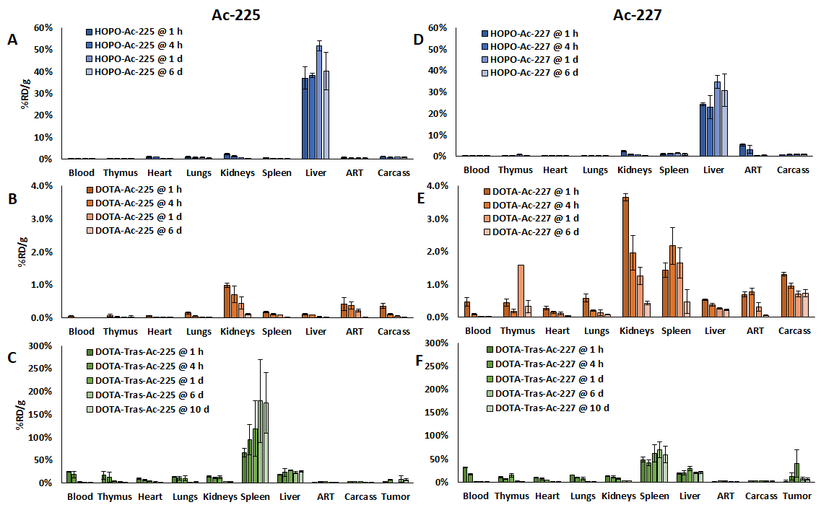

**Figure 2.** %Recovered dose per mass (%RD/g).

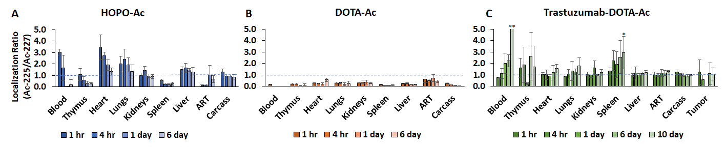

**Figure 3.** Localization ratio (recovered dose per mass of Ac-225/Ac-227). *P-value < 0.05. **value out-of-scale, mean 10.8 ± 19.0 stdev.

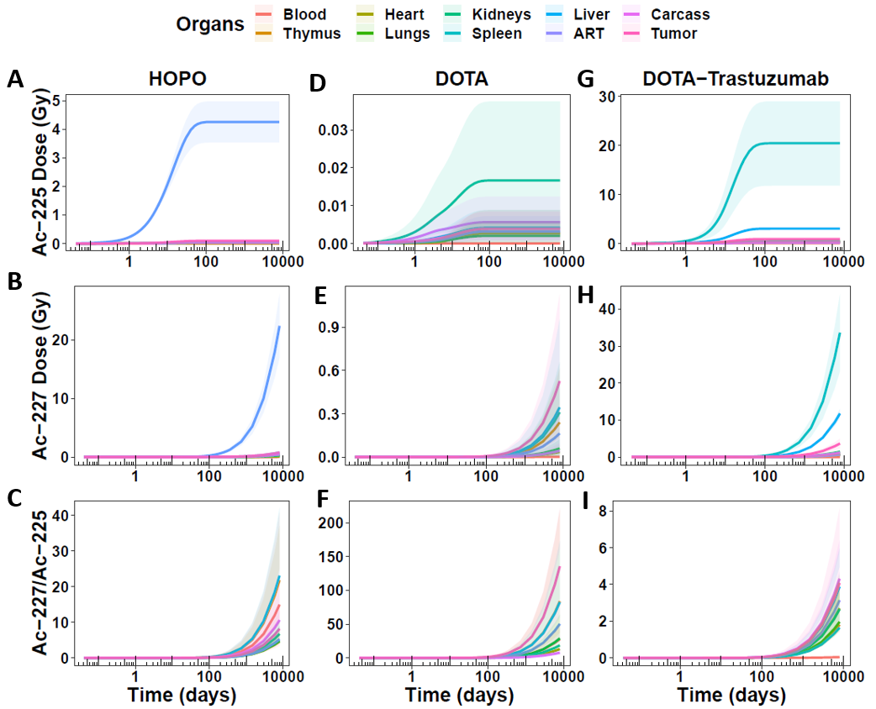

**Figure 4.** Cumulative dose over one Ac-227 half-life (7946 days).

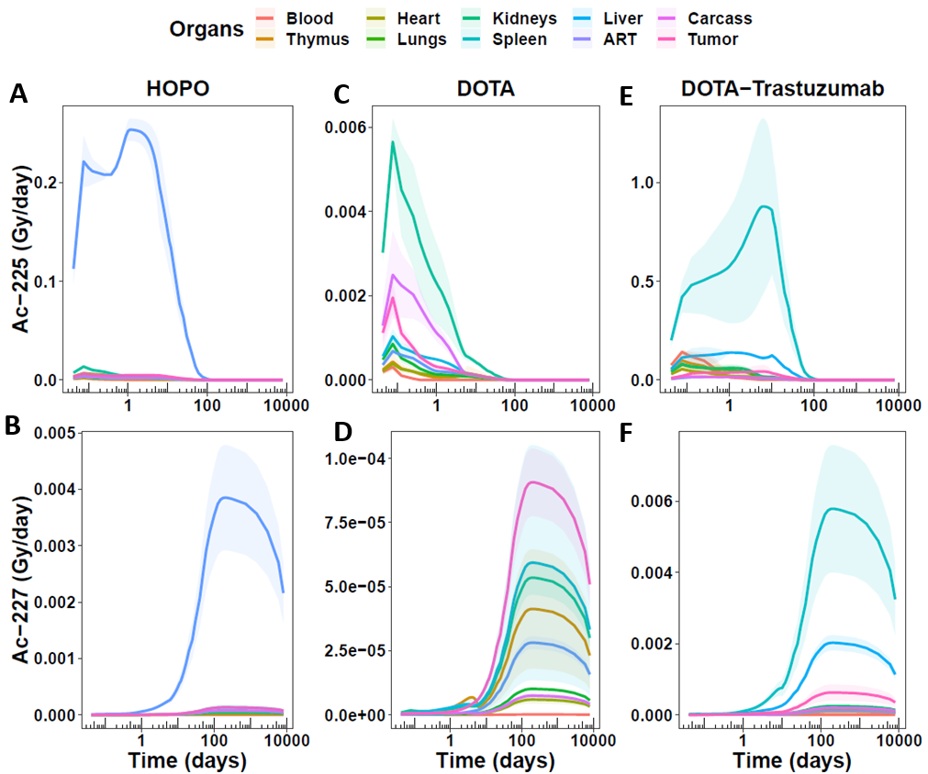

**Figure 5.** Dose per day over one Ac-227 half-life (7946 days).

**DISCLOSURE**

The authors have no disclosures.

**ACKNOWLEDGEMENTS**

This work was supported by

**SUPPLEMENTAL INFORMATION**

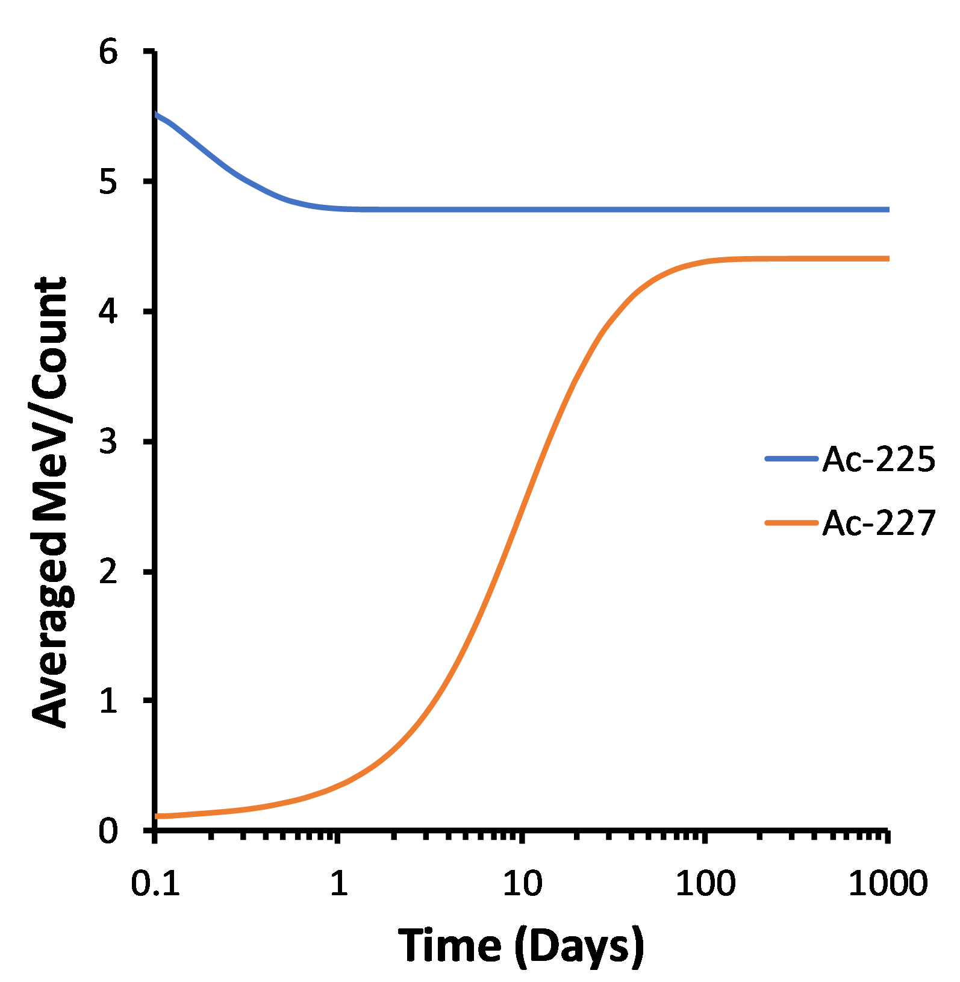

**Figure S1.** Starting with pure actinium species without daughters, equilibrium of average energy per destruction (counting both alpha and beta species) occurs rapidly within one day for Ac-225, and only after 100 days for Ac-227.

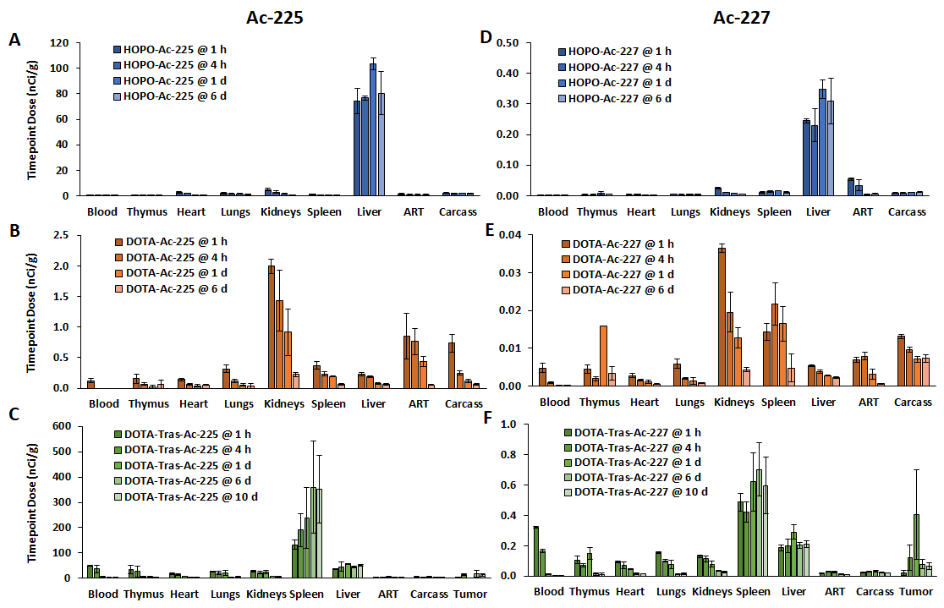

**Figure S2.** Dose biodistribution with exactly 200 nCi Ac-225 and 1 nCi Ac-227 per mouse, based on %RD/g plots in **Figure 2**.

**Figure S3.**

**A**

**B**

**C**

**D**

**E**

**F**

**G**

**H**

**I**

**A**

**B**

**C**

**D**

**E**

**F**